How a Tree’s Life can Change an Ecosystem: Plant Phenology, Gypsy Moths, and Heat Accumulation

November 20, 2019

https://www.neonscience.org/impact/observatory-blog/how-trees-life-can-change-ecosystem-plant-phenology-gypsy-moths-and-heat
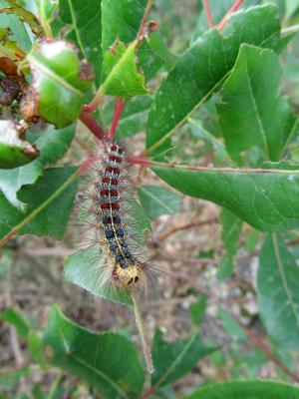
By Karlee Bradley

Imagine walking through the deciduous forests in Massachusetts early one spring. It’s warm enough to enjoy the canopy full of green leaves, after branches have spent a whole winter as leafless sticks. Surrounded by the many oak and maple trees that provide shelter and food for the creatures in the forest, you’re already planning a trip back during the fall season—when the forests will change from green to the orange and gold colors of autumn. Thinking of how most of Massachusetts will look in the fall as you walk deeper into the quiet forest, you begin to hear a calming rain and start to feel raindrops falling down on you.
As you wipe the raindrops off of your face, you look down at your hand and notice that instead of water, you wiped away dirt. Taking a closer look, it seems as though the dirt is actually bits of leaves that have been chewed. Looking up into the forest canopy, you now see the thousands of hairy caterpillars that are covering the trees and realize that the rain you hear and the dirt on your face is the excrement of these caterpillars from eating the leaves of the trees you stand under. These forest pests are the larvae of the gypsy moth.

The Gypsy Moth
Lymantria dispar, commonly known as the gypsy moth, is native to the forests of Europe and was first introduced into Massachusetts in the late 1800s. This invasive species has since spread as far west as Minnesota and as far south as North Carolina. The gypsy moth does not have many natural predators in the United States, contributing to this species’ ability to continue breeding and, ultimately, dominating where it inhabits.
Gypsy moth caterpillars primarily feed on the leaves of deciduous broadleaf trees, and they have been known to completely defoliate groves of entire trees. When springs are more wet and experience a large amount of rainfall leaving trees hydrated and more resilient to destruction, gypsy moth populations are often kept under control due to a fungus called Entomophaga maimaiga which thrives in wet conditions. Known as the “caterpillar killer,” this fungus infects and kills gypsy moth larvae. However, when temperatures increase and precipitation regimes change over multiple years, leaving forests exposed to drought-like conditions, gypsy moth populations can also increase, and deciduous broadleaf trees can become more vulnerable to the damage of the larvae. For example, if springs are drier because of higher temperatures, the life cycle of Entomophaga maimaiga is impeded, allowing for higher populations of gypsy moths. With more gypsy moths, the defoliation damage to these drought-stricken trees is more severe, leaving them more susceptible to die after a serious defoliation event.
The consequences of severe deciduous broadleaf defoliation are wide-ranging. When particularly large numbers of leaves are consumed, the ecohydrology—interactions between water and ecological systems—and local weather in the area may be affected by the loss of the canopy. Less canopy coverage over water sources can lead to increased water temperatures which in turn encourage production of harmful algae blooms. This rapid growth of algae can lower the oxygen levels in the water creating domino effect within the aquatic food web.
Defoliation also disrupts the important nutrient cycles within a forest. Typically, leaves from deciduous broadleaf trees drop after they have changed colors in the fall, and these fallen, dead leaves supply a source of carbon to the microbes in the soil. These microbes decompose organic matter, are important regulators in the carbon cycle, and are necessary in maintaining nutrient balance within the soil. When gypsy moths defoliate forests in the spring, soil microbes receive caterpillar frass (excrement) rather than as fallen leaves in the fall. The quality of the organic carbon in frass differs from leaf organic matter, so not only are there differences in timing, there are also differences in the types of microbes that will consume the organic matter.
Small mammals, birds, and native insects that rely on these trees for food and shelter may also suffer from the loss of their food source and protection. With a destructed habitat, these animals’ survival is in jeopardy, and the stability of their food web is at risk.

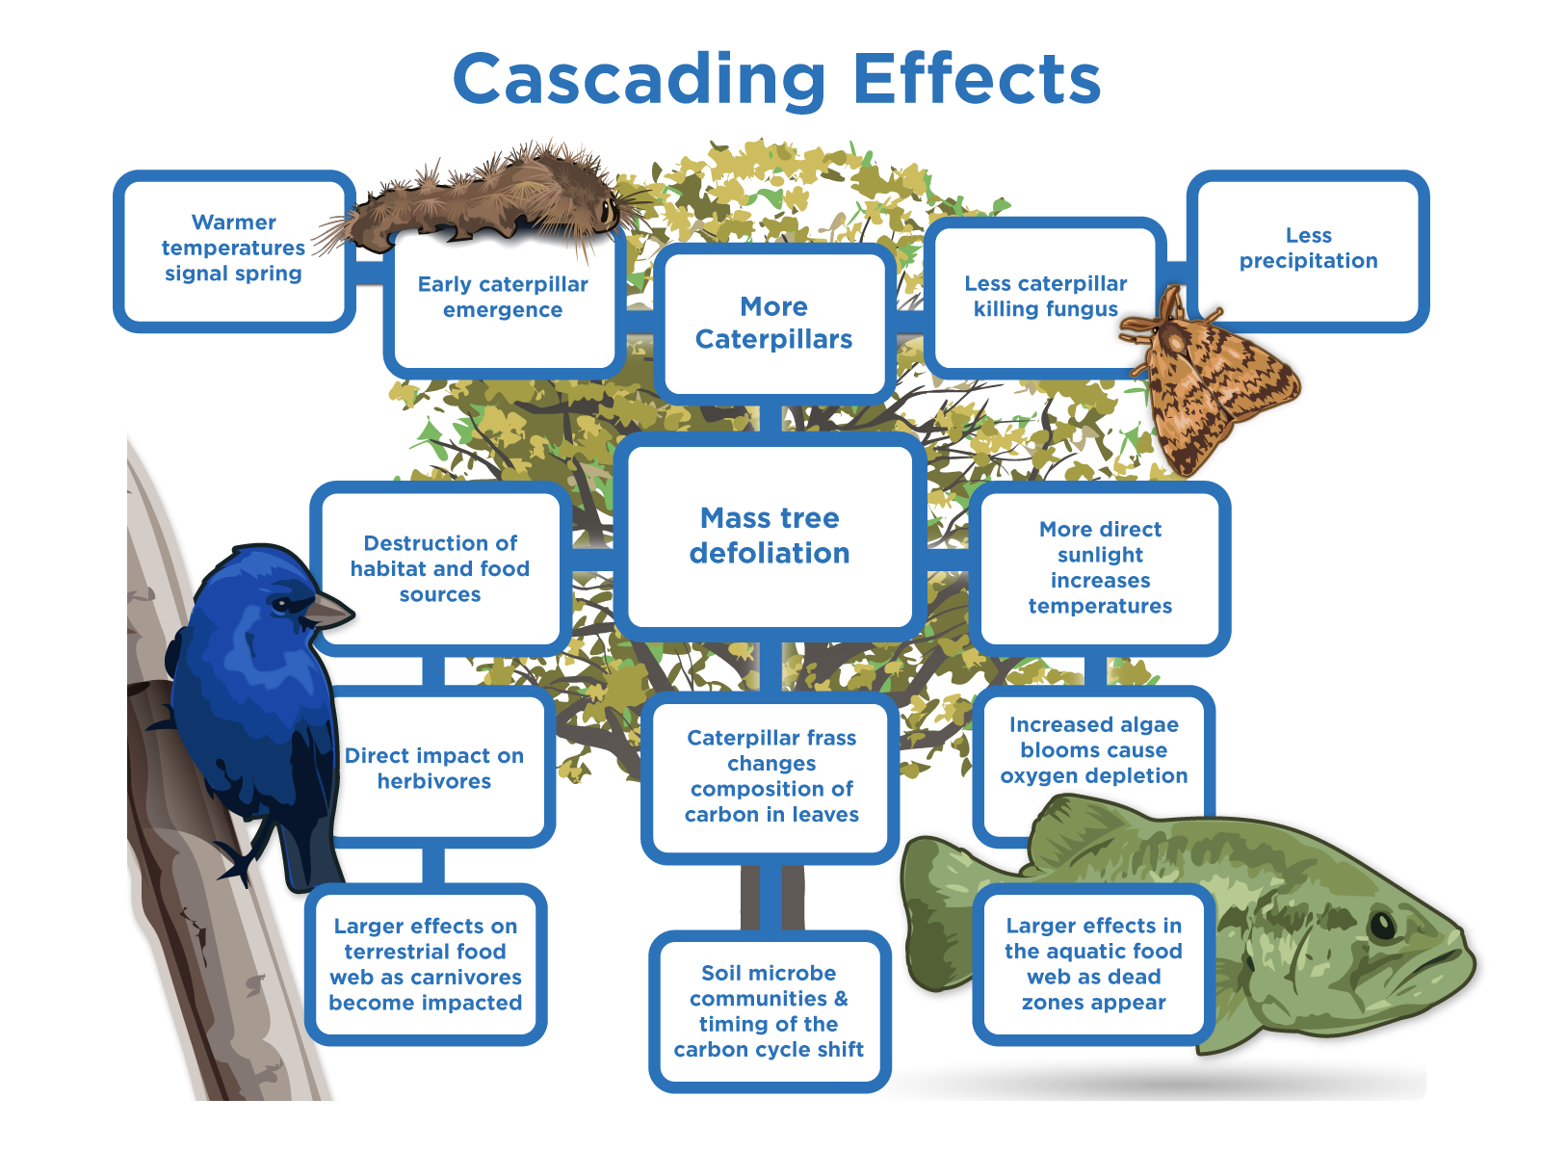
This diagram shows the effects that warmer temperatures and decreased precipitation can have on the gypsy moth and the deciduous broadleaf trees along with the consequences and interactions throughout the whole terrestrial and aquatic ecosystem. Image credit: National Ecological Observatory Network, Battelle.

